WEB SERVER SCANNING REPORT USING NIKTO
Practical / Lab Report

Aim
To perform a basic web-server security assessment using the Nikto web server scanner and observe the information and potential configuration issues reported by the tool. Scanning should be performed only on systems for which explicit authorization has been obtained.

Tools Required
• Nikto v2.6.1
• Terminal / command-line interface
• Authorized test environment and network connection

Procedure
- Open the terminal in the authorized testing environment.
- Run Nikto against the approved target hostname using the appropriate command-line options.
- Review the target information reported by Nikto, including the resolved IP address, hostname, port, and server banner.
- Observe any warnings, unusual headers, allowed HTTP methods, and errors shown in the scan output.
- Record the findings and note that scanner output may contain false positives and does not by itself confirm a vulnerability.
- Stop testing if authorization is absent or the target owner has not approved the scan.

Observation / Output
The supplied screenshot shows two Nikto scan sessions. The first targets www.zoho.com on port 80; the output identifies Cloudflare and reports that multiple IP addresses were found. The scan also shows an error-limit message while reading the HTTP response and recommends considering a proxy because of TLS fingerprint blocks.
The second session targets www.certifiedhacker.com on port 80. The output identifies nginx/1.29.8 and reports unusual headers, a changed server banner, and the HTTP methods GET, POST, OPTIONS, and HEAD. It also reports response-reading errors and says the running average did not have enough data.
These are observations from the screenshot only. They do not establish that either site is vulnerable, and the screenshot does not show a complete or conclusive assessment.

Screenshot
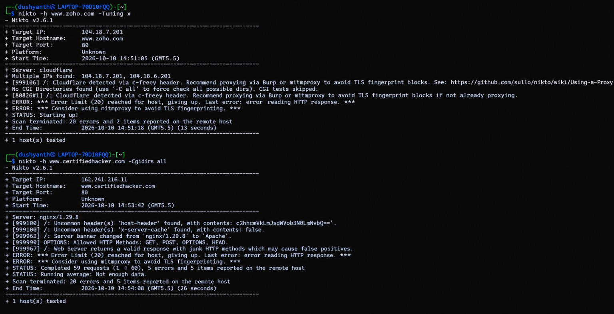

Result
Nikto was used to collect basic web-server information from the two targets shown in the supplied terminal screenshot. The output displayed server/header observations and scan errors. Because the scans encountered response-reading errors and limited data, the findings should be treated as preliminary and should not be interpreted as proof of a security vulnerability.

Conclusion
The practical demonstrates how Nikto can report web-server banners, HTTP methods, and unusual headers. Further validation should be carried out only with the target owner's written permission and using an approved testing scope.

